CS 255 System Design Document Template

UML Diagrams

UML Use Case Diagram

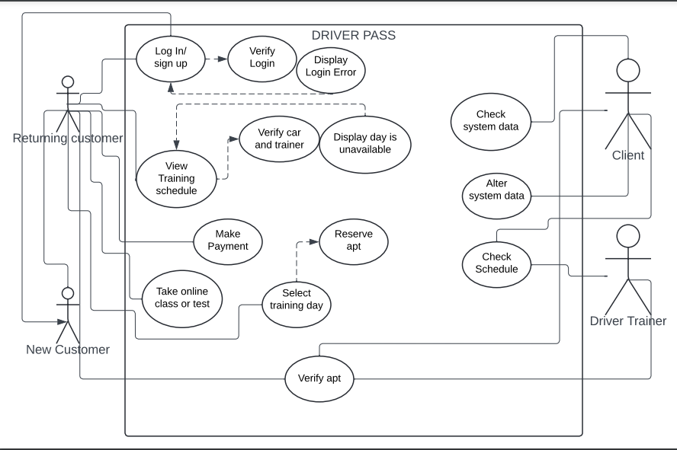

UML Activity Diagrams
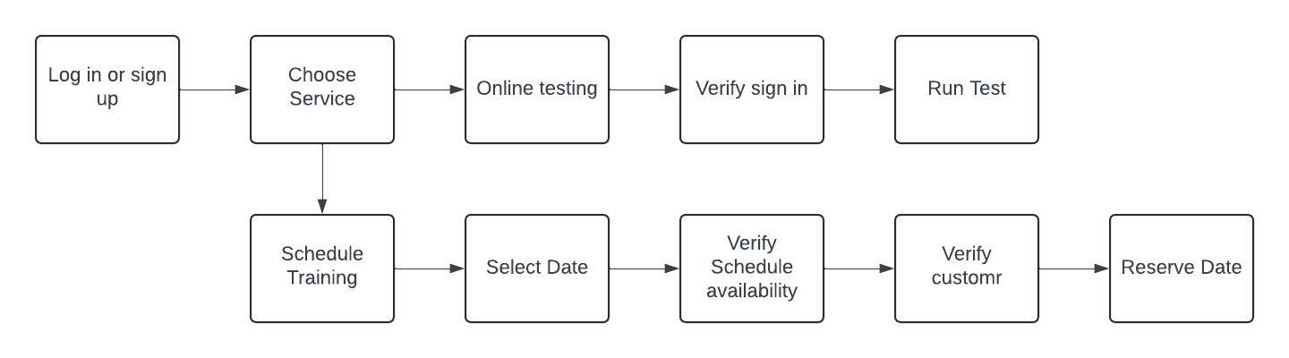
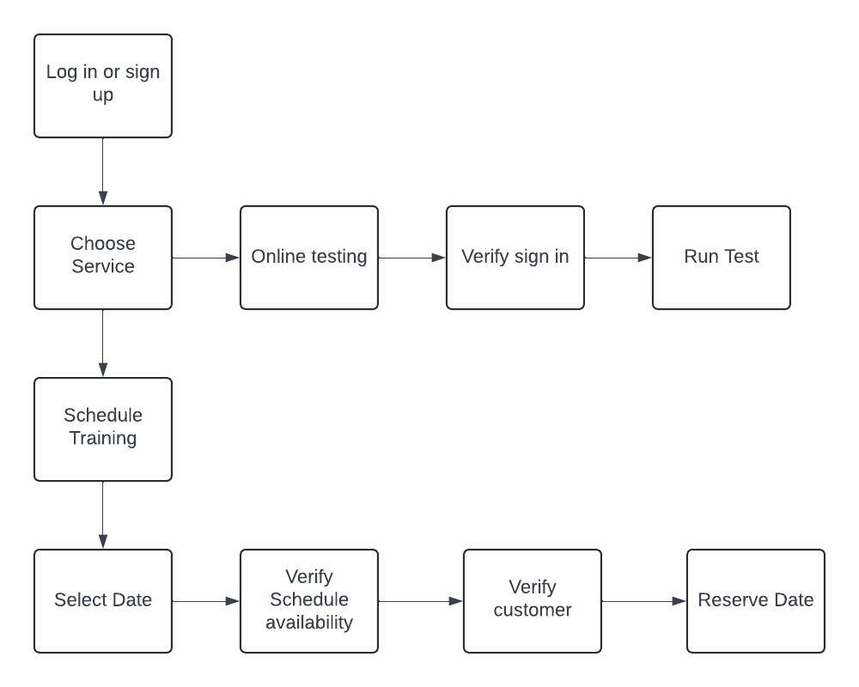

UML Sequence Diagram
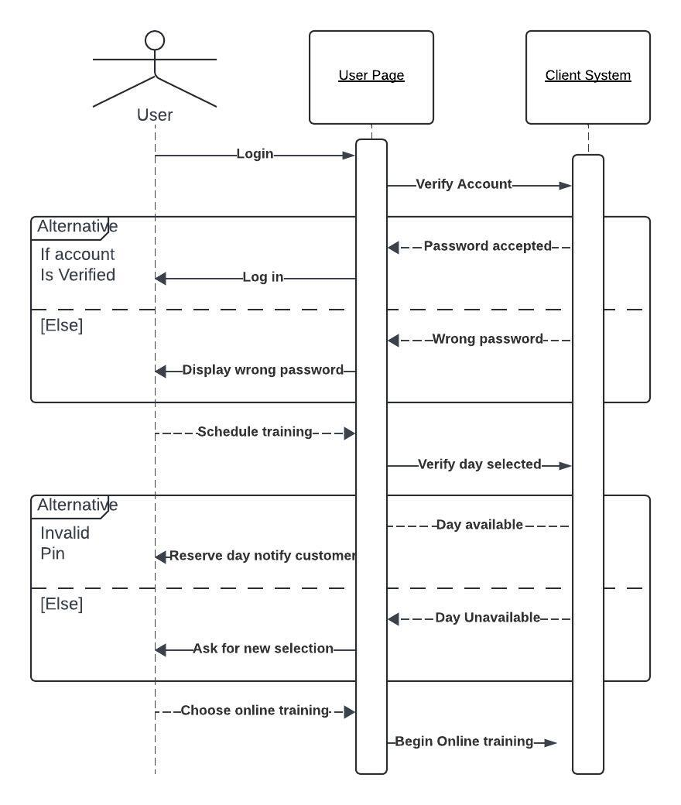

UML Class Diagram
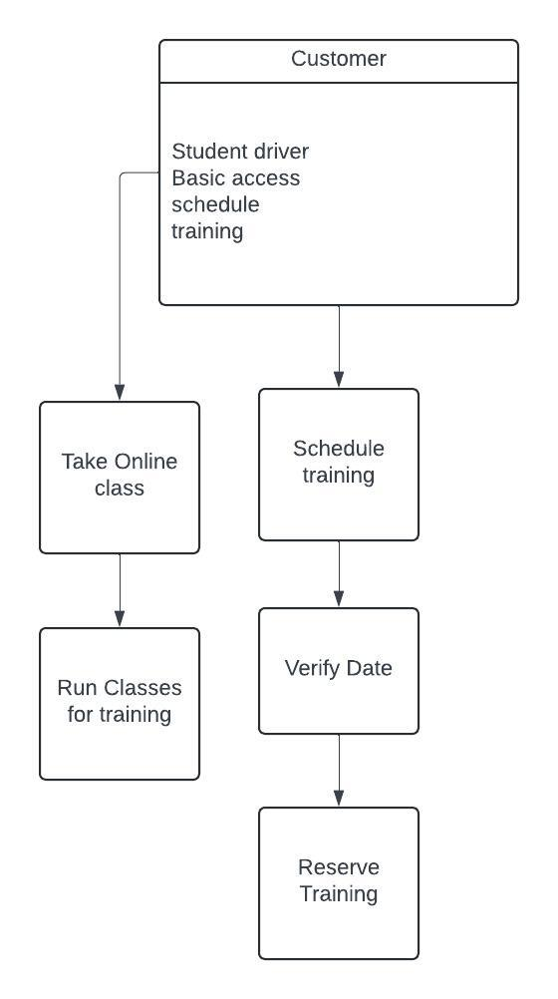

Technical Requirements

This software needs to be able to run on multiple platforms. Mainly mobile and desktop, and the customer needs to be able to utilize the same features on both. The customer needs to be able to either take a class online or schedule driving practice with a trainer. There are going to be 3 levels of service provided, each with varying differences in training. The system needs to be able to track and update schedule changes in real time. The client needs access to the system and the ability to give different employees different access.

